Day 1 - Jenkins - Introduction

Task : Launch jenkins and explore creating projects and users.

Install Jenkins :

Install jenkins in ubuntu

sudo wget -O /usr/share/keyrings/jenkins-keyring.asc \

https://pkg.jenkins.io/debian-stable/jenkins.io-2023.key

echo "deb [signed-by=/usr/share/keyrings/jenkins-keyring.asc]" \

https://pkg.jenkins.io/debian-stable binary/ | sudo tee \

/etc/apt/sources.list.d/jenkins.list > /dev/null

sudo apt-get update

sudo apt-get install jenkins

Install java for jenkins

sudo apt update

sudo apt install fontconfig openjdk-17-jre

java -version

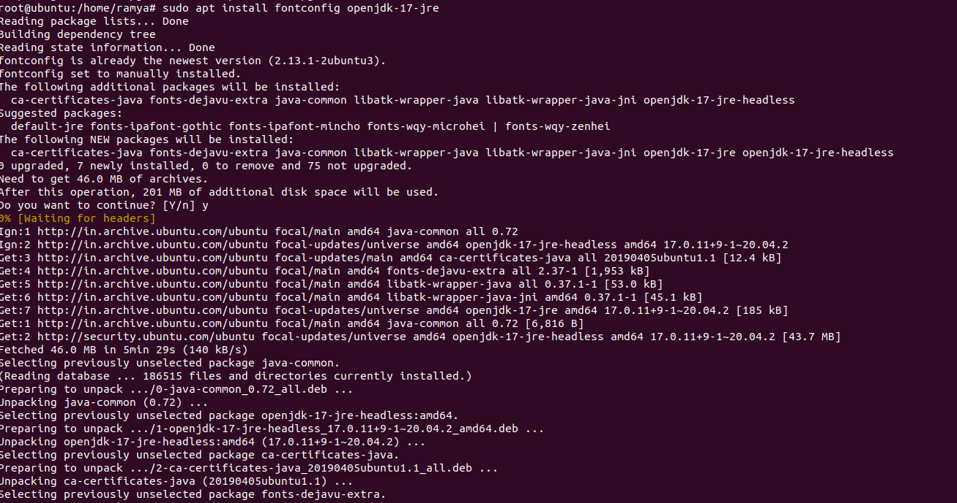

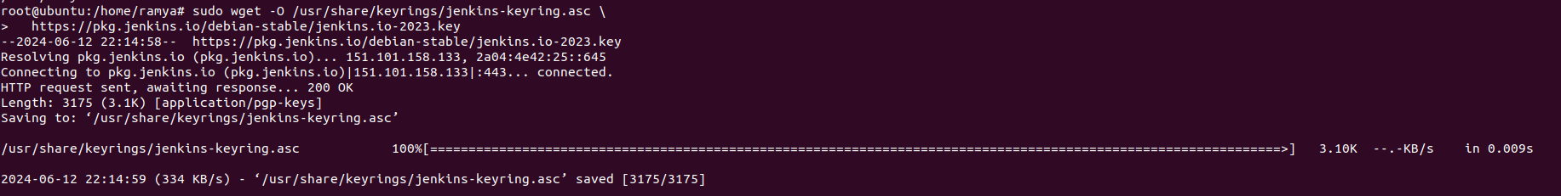

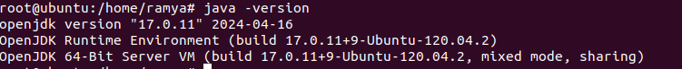

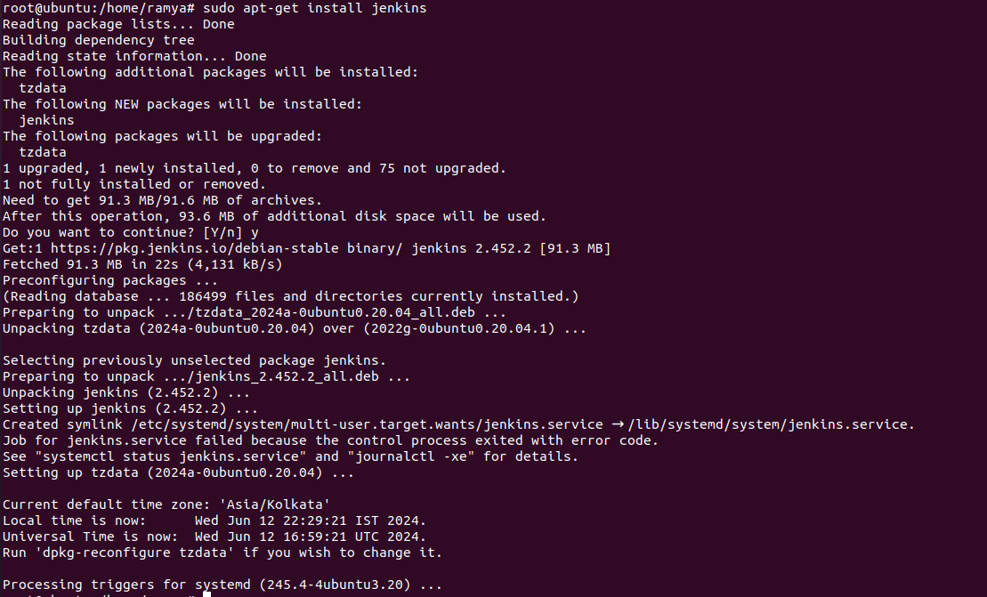

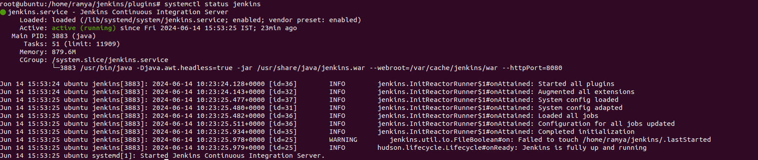

Launch Jenkins

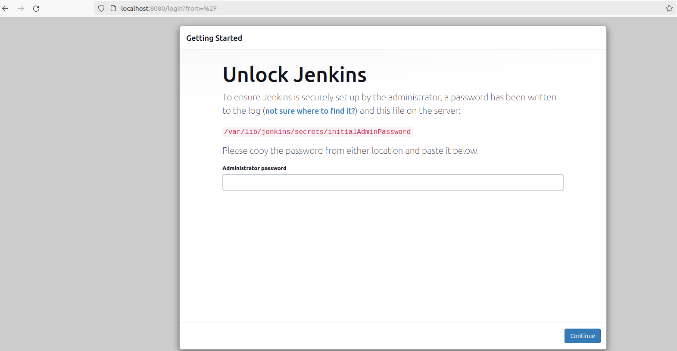

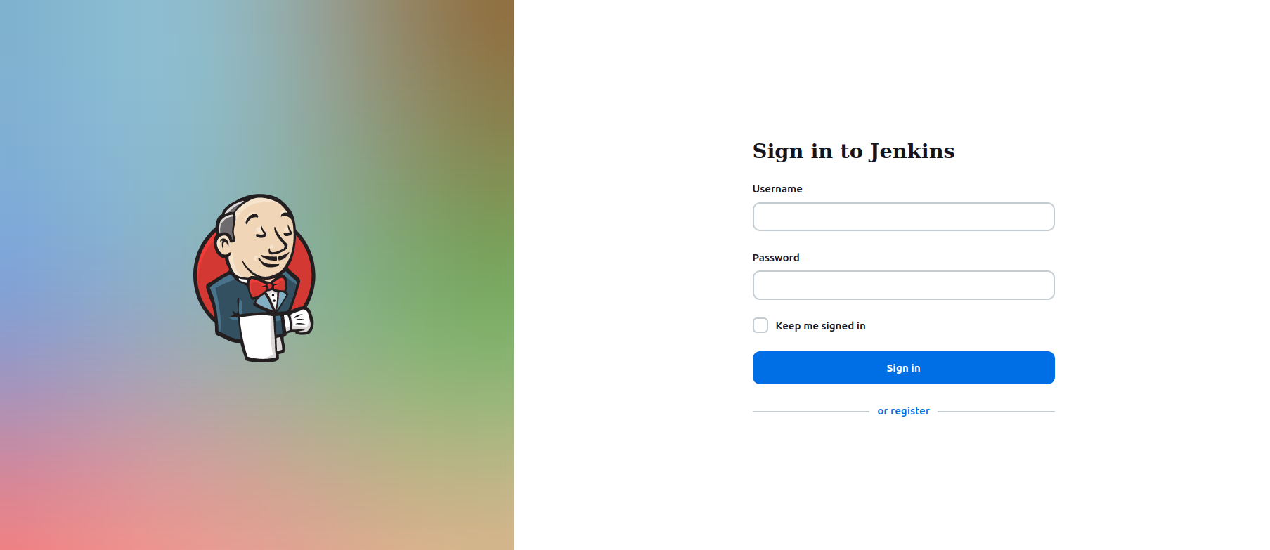

Create user

Click on user

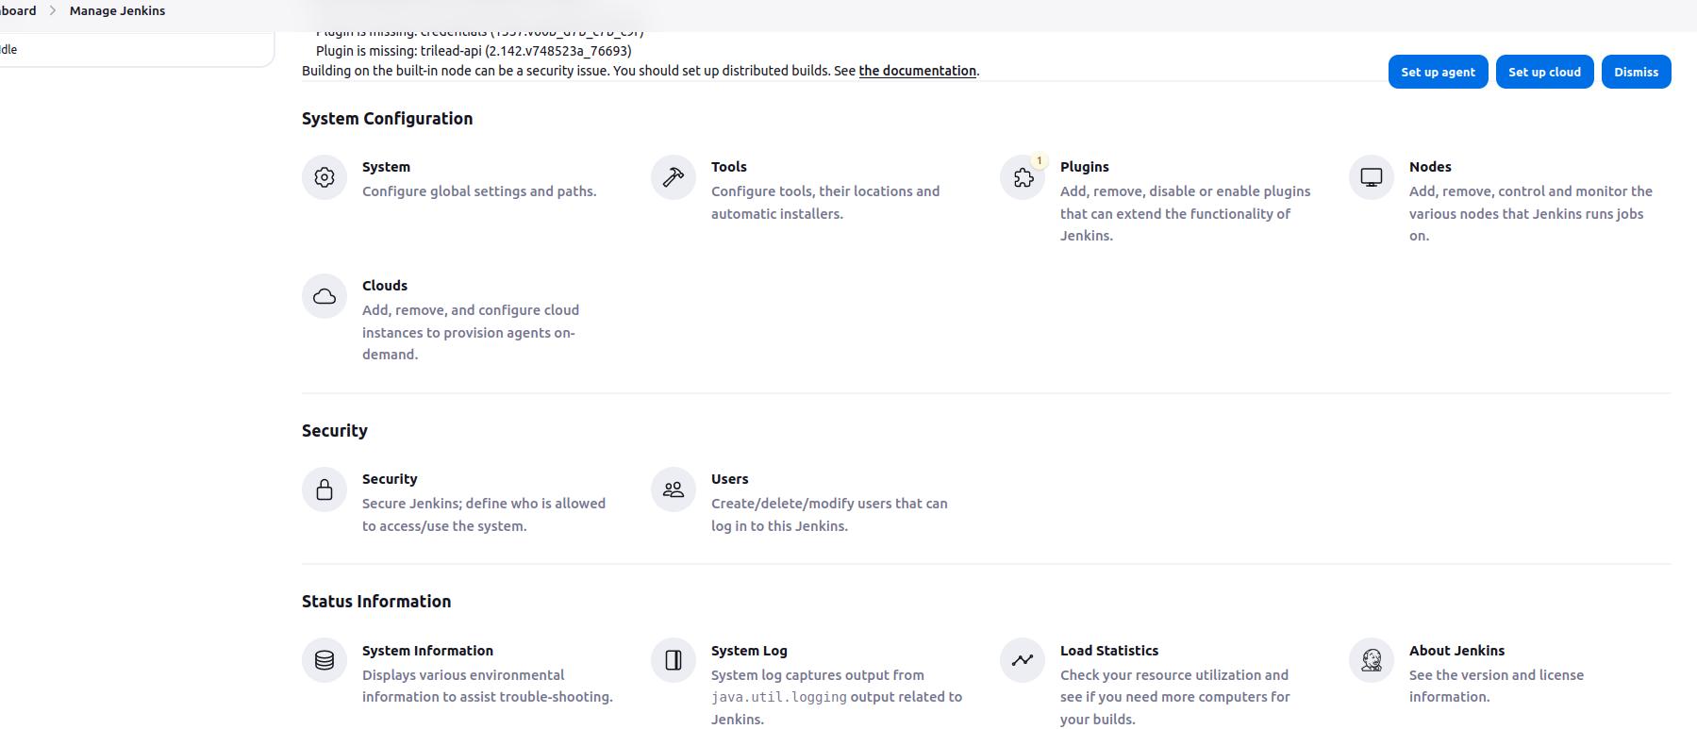

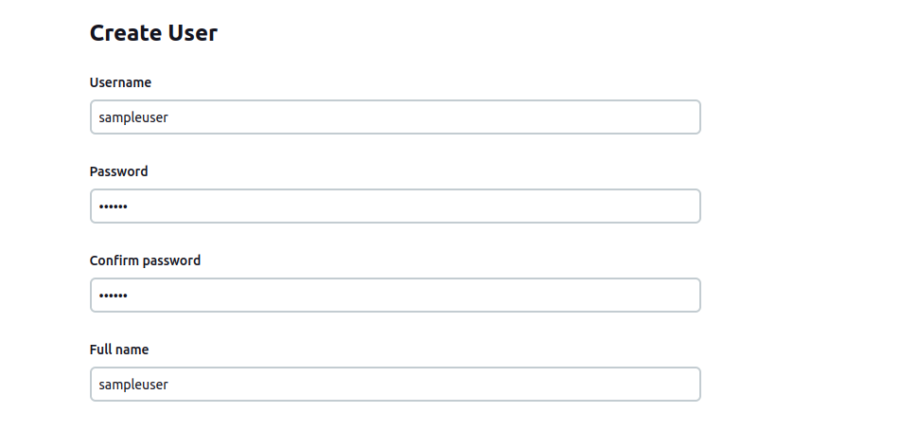

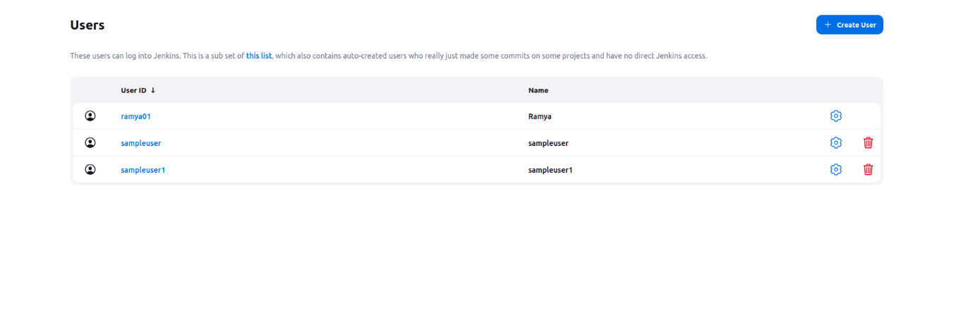

Login with that user created

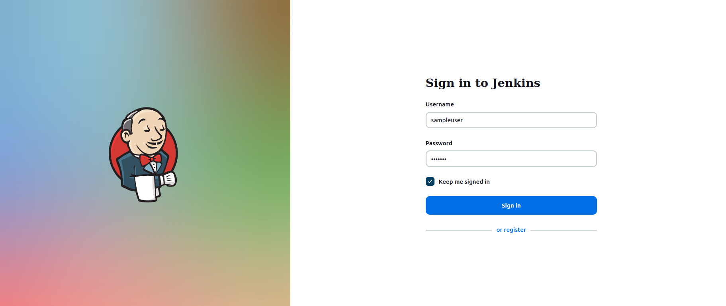

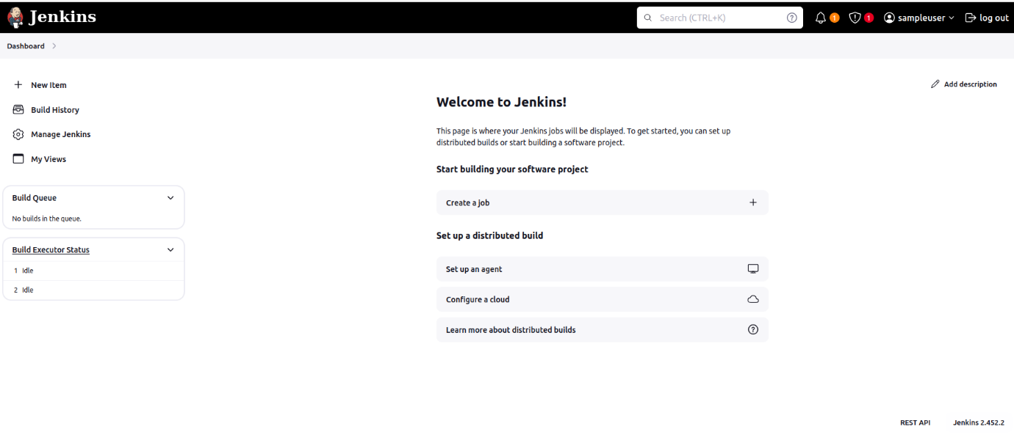

Create one sample project

